**Spring REST using Spring Boot 3**

**1. Create a Spring Web Project using Maven**

**STEP 1:** Create Spring Boot Project using Spring Initializer

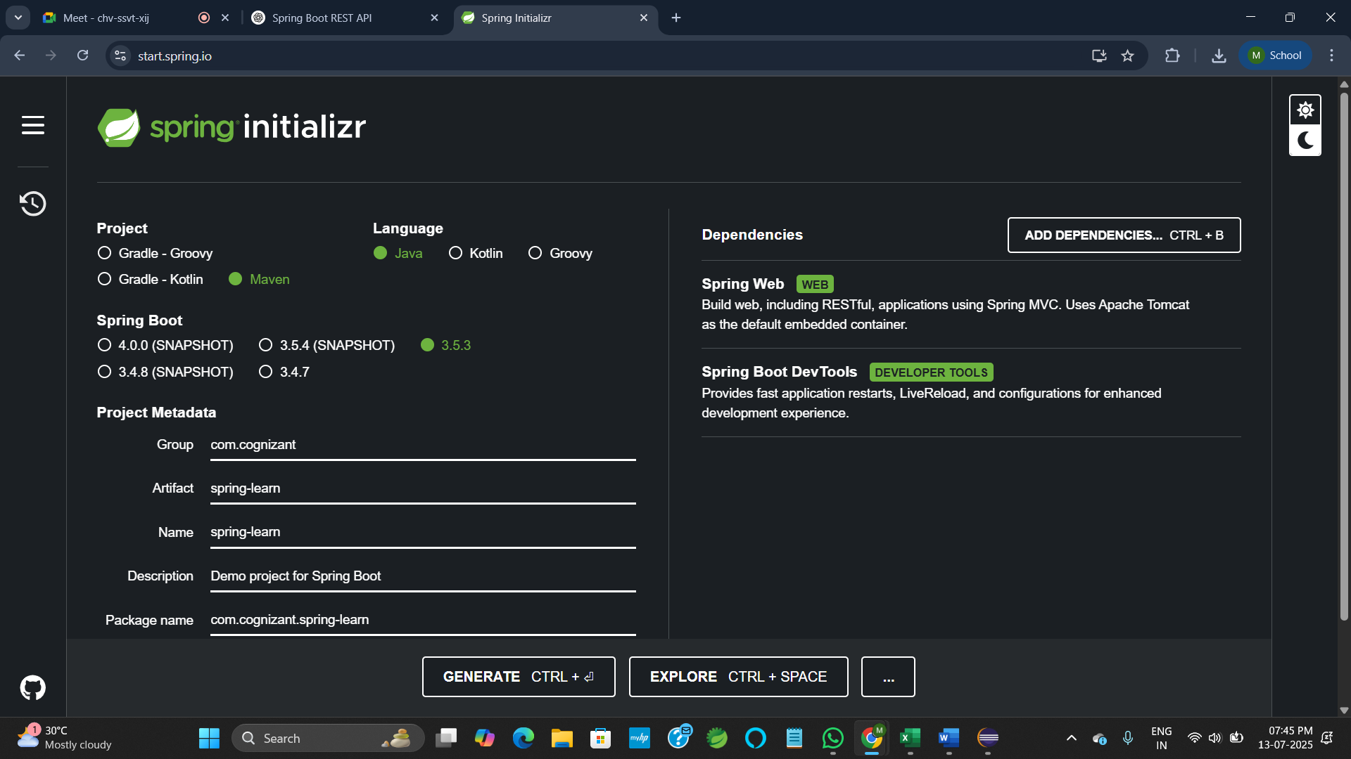

**STEP 2:** Import Project in Eclipse

**STEP 3:** Add Logging to Main Class

**SpringLearnApplication.java**

package com.cognizant.spring_learn;

import org.slf4j.Logger;

import org.slf4j.LoggerFactory;

import org.springframework.boot.SpringApplication;

import org.springframework.boot.autoconfigure.SpringBootApplication;

*@SpringBootApplication*

public class SpringLearnApplication {

private static final Logger ***LOGGER*** = LoggerFactory.*getLogger*(SpringLearnApplication.class);

public static void main(String[] args) {

SpringApplication.*run*(SpringLearnApplication.class, args);

***LOGGER***.info("START");

***LOGGER***.info("END");

} }

**OUTPUT:**

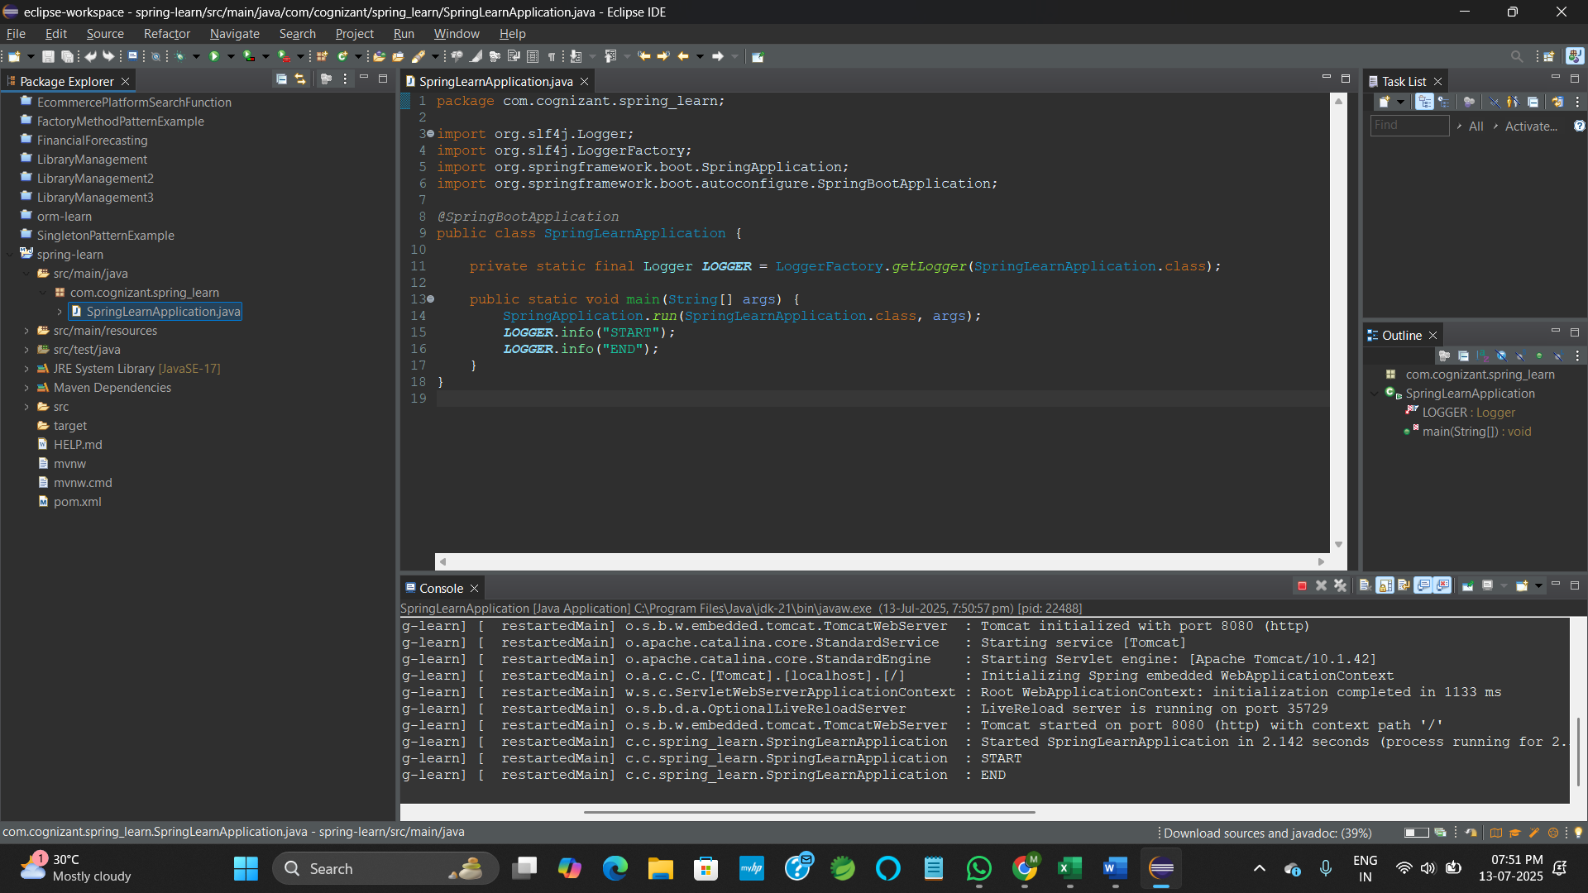

**2. Spring Core – Load Country from Spring Configuration XML**

**country.xml**

<?xml version="1.0" encoding="UTF-8"?>

<beans xmlns="http://www.springframework.org/schema/beans"

xmlns:xsi="http://www.w3.org/2001/XMLSchema-instance"

xsi:schemaLocation="

http://www.springframework.org/schema/beans

http://www.springframework.org/schema/beans/spring-beans.xsd">

<bean id="country" class="com.cognizant.spring_learn.Country">

<property name="code" value="IN" />

<property name="name" value="India" />

</bean>

</beans>

**Country.java**

package com.cognizant.spring_learn;

import org.slf4j.Logger;

import org.slf4j.LoggerFactory;

public class Country {

private static final Logger ***LOGGER*** = LoggerFactory.*getLogger*(Country.class);

private String code;

private String name;

public Country() {

***LOGGER***.debug("Inside Country Constructor.");

}

public String getCode() {

***LOGGER***.debug("Inside getCode()");

return code;

}

public void setCode(String code) {

***LOGGER***.debug("Inside setCode()");

this.code = code;

}

public String getName() {

***LOGGER***.debug("Inside getName()");

return name;

}

public void setName(String name) {

***LOGGER***.debug("Inside setName()");

this.name = name;

}

*@Override*

public String toString() {

return "Country [code=" + code + ", name=" + name + "]";

}

}

**SpringLearnApplication.java**

package com.cognizant.spring_learn;

import org.springframework.boot.SpringApplication;

import org.springframework.boot.autoconfigure.SpringBootApplication;

import org.springframework.context.ApplicationContext;

import org.springframework.context.support.ClassPathXmlApplicationContext;

import org.slf4j.Logger;

import org.slf4j.LoggerFactory;

@SpringBootApplication

public class SpringLearnApplication {

private static final Logger LOGGER = LoggerFactory.getLogger(SpringLearnApplication.class);

public static void displayCountry() {

ApplicationContext context = new ClassPathXmlApplicationContext("country.xml");

Country country = (Country) context.getBean("country", Country.class);

LOGGER.debug("Country : {}", country.toString());

}

public static void main(String[] args) {

SpringApplication.run(SpringLearnApplication.class, args);

LOGGER.info("START");

displayCountry();

LOGGER.info("END");

}

}

**application.properties**

spring.application.name=spring_learn

server.port=8087

logging.level.root=DEBUG

**OUTPUT:**

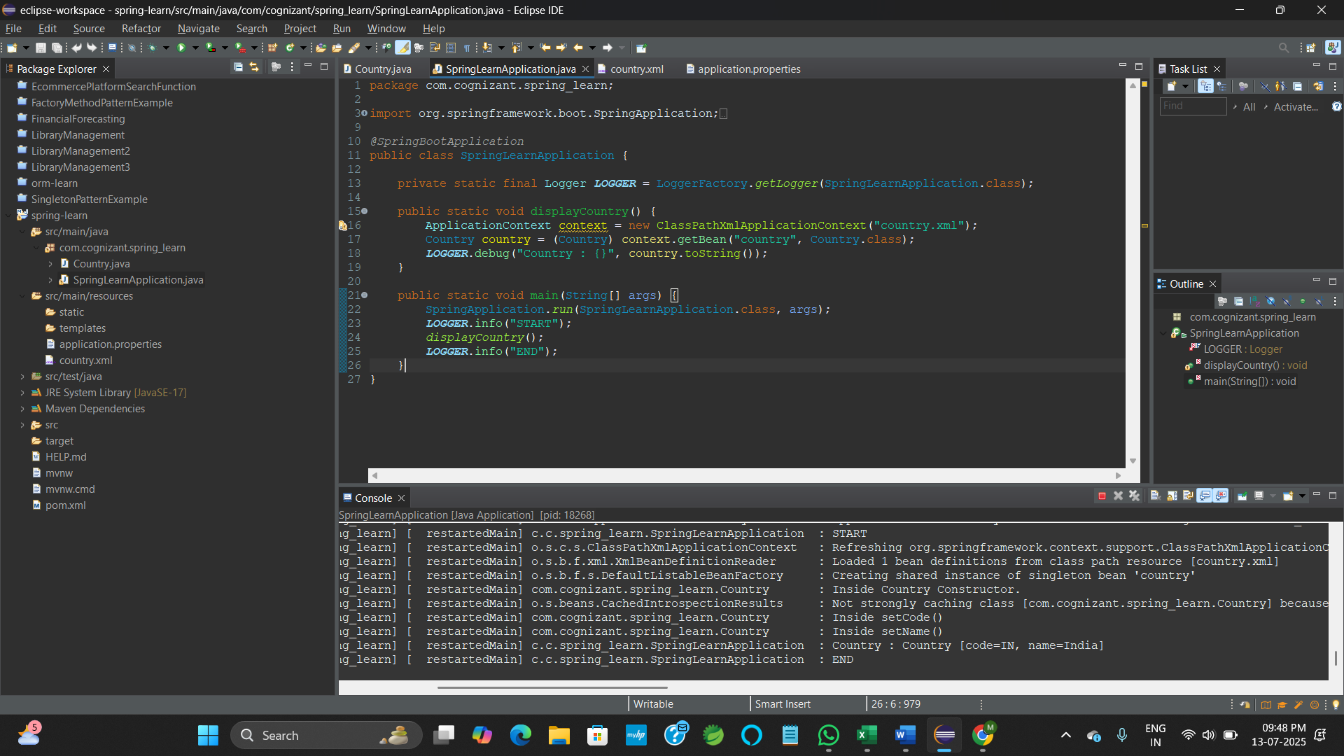

**3. Hello World RESTful Web Service**

**HelloController.java**

package com.cognizant.spring_learn.controller;

import org.slf4j.Logger;

import org.slf4j.LoggerFactory;

import org.springframework.web.bind.annotation.GetMapping;

import org.springframework.web.bind.annotation.RestController;

*@RestController*

public class HelloController {

private static final Logger ***LOGGER*** = LoggerFactory.*getLogger*(HelloController.class);

*@GetMapping*("/hello")

public String sayHello() {

***LOGGER***.info("START - sayHello()");

***LOGGER***.info("END - sayHello()");

return "Hello World!! Welcome to Cognizant Deepskilling!!!";

}

}

**SpringLearnApplication.java**

package com.cognizant.spring_learn;

import org.springframework.boot.SpringApplication;

import org.springframework.boot.autoconfigure.SpringBootApplication;

import org.springframework.context.ApplicationContext;

import org.springframework.context.support.ClassPathXmlApplicationContext;

import org.slf4j.Logger;

import org.slf4j.LoggerFactory;

@SpringBootApplication

public class SpringLearnApplication {

private static final Logger LOGGER = LoggerFactory.getLogger(SpringLearnApplication.class);

public static void displayCountry() {

ApplicationContext context = new ClassPathXmlApplicationContext("country.xml");

Country country = (Country) context.getBean("country", Country.class);

LOGGER.debug("Country : {}", country.toString());

}

public static void main(String[] args) {

SpringApplication.run(SpringLearnApplication.class, args);

LOGGER.info("START");

displayCountry();

LOGGER.info("END");

}

}

**application.properties**

spring.application.name=spring_learn

server.port=8025

logging.level.root=DEBUG

**OUTPUT:**



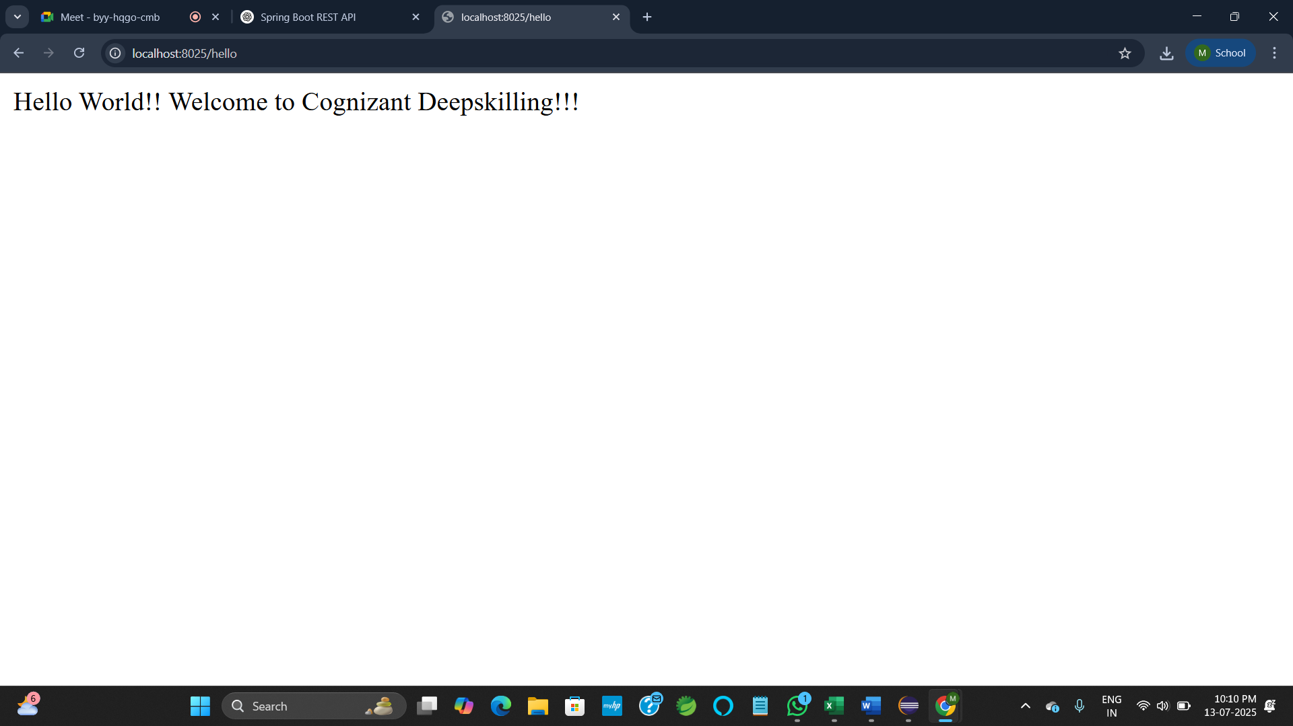

**4. REST - Country Web Service**

**CountryController.java**

package com.cognizant.spring_learn.controller;

import com.cognizant.spring_learn.Country;

import org.slf4j.Logger;

import org.slf4j.LoggerFactory;

import org.springframework.context.ApplicationContext;

import org.springframework.context.support.ClassPathXmlApplicationContext;

import org.springframework.web.bind.annotation.RequestMapping;

import org.springframework.web.bind.annotation.RestController;

*@RestController*

public class CountryController {

private static final Logger ***LOGGER*** = LoggerFactory.*getLogger*(CountryController.class);

*@RequestMapping*("/country")

public Country getCountryIndia() {

***LOGGER***.info("START - getCountryIndia()");

ApplicationContext context = new ClassPathXmlApplicationContext("country.xml");

Country country = (Country) context.getBean("country", Country.class);

***LOGGER***.debug("Country: {}", country);

***LOGGER***.info("END - getCountryIndia()");

return country;

}

}

**application.properties**

spring.application.name=spring_learn

server.port=3745

logging.level.root=DEBUG

**SpringLearnApplication.java**

package com.cognizant.spring_learn;

import org.springframework.boot.SpringApplication;

import org.springframework.context.ApplicationContext;

import org.springframework.context.support.ClassPathXmlApplicationContext;

import org.slf4j.Logger;

import org.slf4j.LoggerFactory;

@SpringBootApplication

public class SpringLearnApplication {

private static final Logger LOGGER = LoggerFactory.getLogger(SpringLearnApplication.class);

public static void displayCountry() {

ApplicationContext context = new ClassPathXmlApplicationContext("country.xml");

Country country = (Country) context.getBean("country", Country.class);

LOGGER.debug("Country : {}", country.toString());

}

public static void main(String[] args) {

SpringApplication.run(SpringLearnApplication.class, args);

LOGGER.info("START");

displayCountry();

LOGGER.info("END");

} }

**country.xml**

<?xml version="1.0" encoding="UTF-8"?>

<beans xmlns="http://www.springframework.org/schema/beans"

xmlns:xsi="http://www.w3.org/2001/XMLSchema-instance"

xsi:schemaLocation="

http://www.springframework.org/schema/beans

http://www.springframework.org/schema/beans/spring-beans.xsd">

<bean id="country" class="com.cognizant.spring_learn.Country">

<property name="code" value="IN" />

<property name="name" value="India" />

</bean>

</beans>

**OUTPUT:**

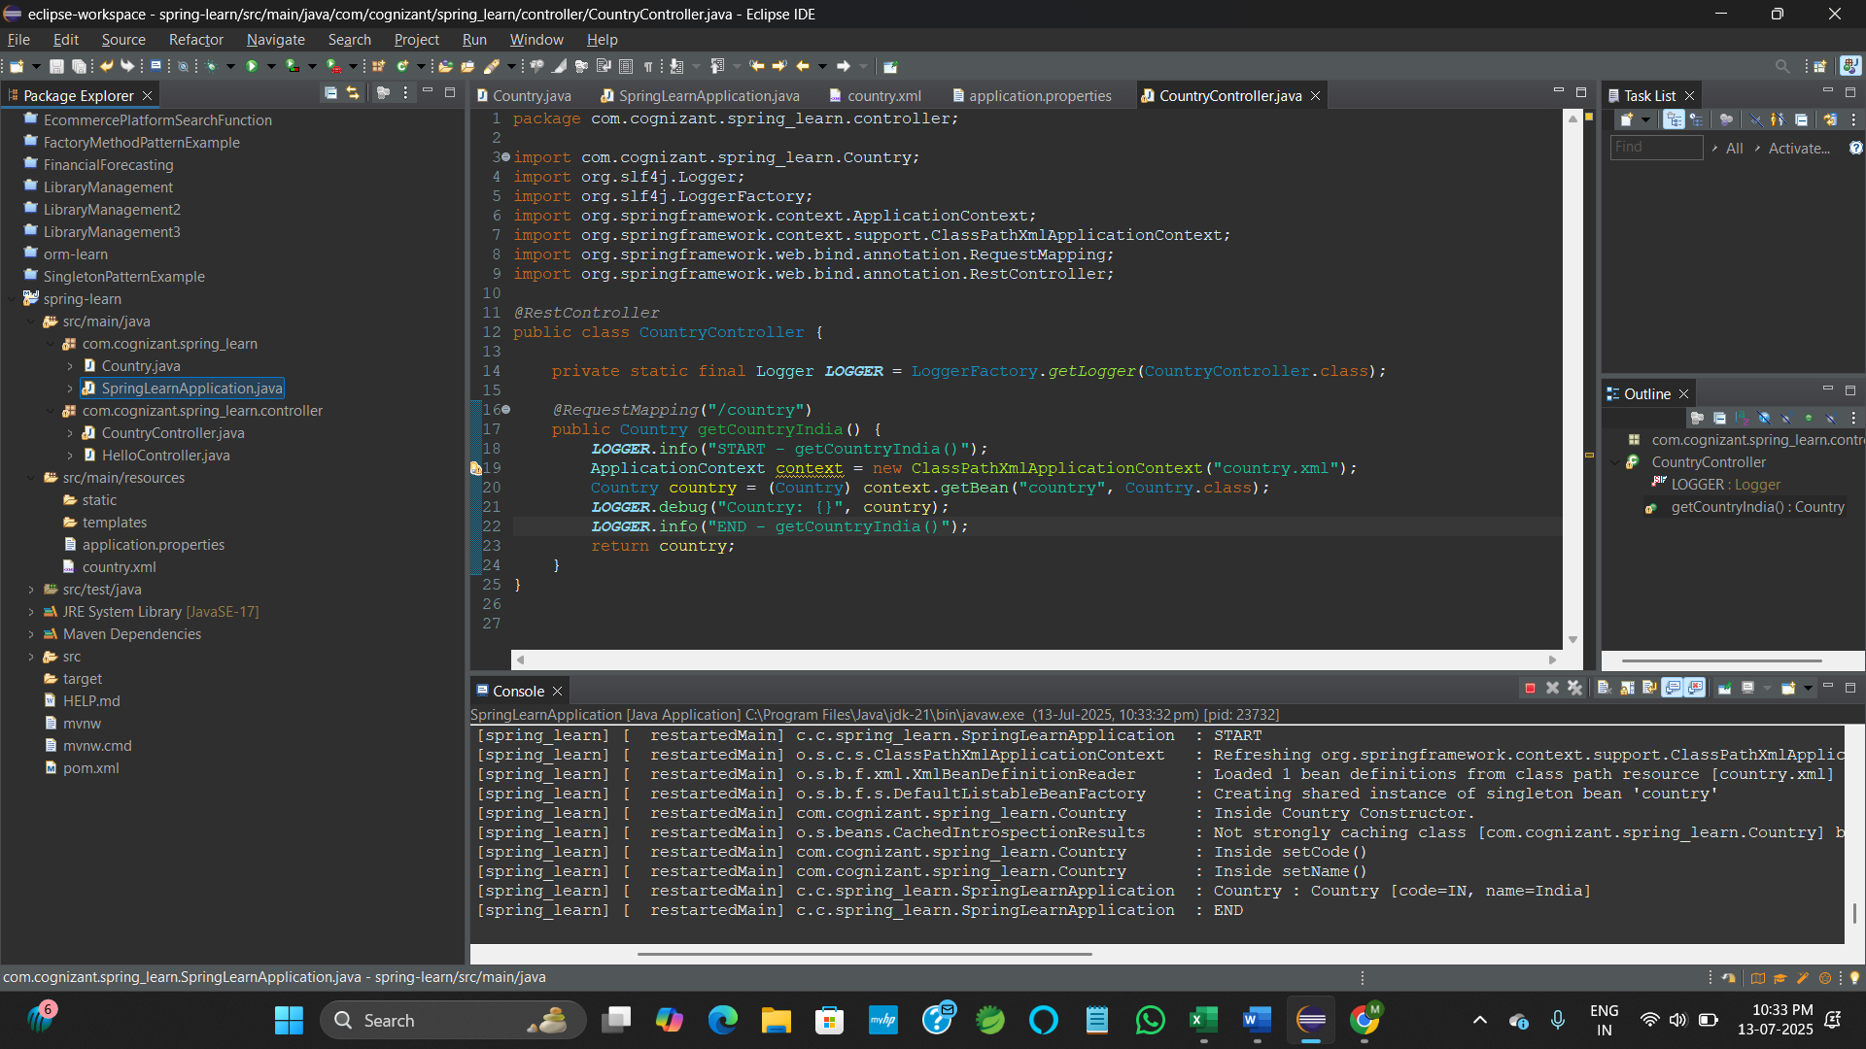

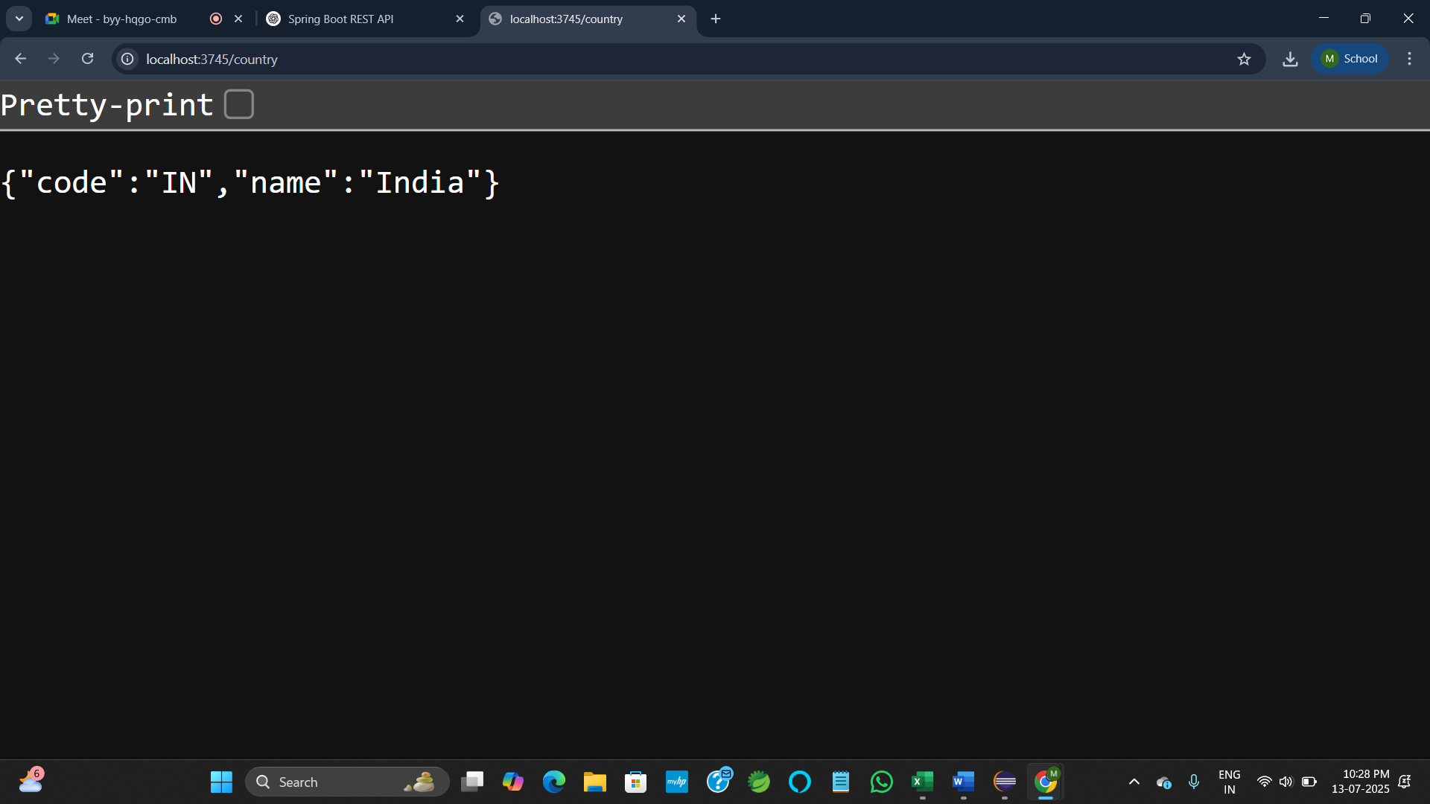

**5. REST - Get country based on country code**

**CountryService.java**

package com.cognizant.spring_learn.controller;

import com.cognizant.spring_learn.service.CountryService;

import org.slf4j.Logger;

import org.slf4j.LoggerFactory;

import org.springframework.beans.factory.annotation.Autowired;

import org.springframework.context.support.ClassPathXmlApplicationContext;

import org.springframework.web.bind.annotation.GetMapping;

import org.springframework.web.bind.annotation.PathVariable;

import org.springframework.web.bind.annotation.RequestMapping;

import org.springframework.web.bind.annotation.RestController;

*@RestController*

public class CountryController {

private static final Logger ***LOGGER*** = LoggerFactory.*getLogger*(CountryController.class);

*@RequestMapping*("/country")

public Country getCountryIndia() {

***LOGGER***.info("START - getCountryIndia()");

ApplicationContext context = new ClassPathXmlApplicationContext("country.xml");

Country country = (Country) context.getBean("country", Country.class);

***LOGGER***.debug("Country: {}", country);

***LOGGER***.info("END - getCountryIndia()");

return country;

}

*@Autowired*

private CountryService countryService;

*@GetMapping*("/country/{code}")

public Country getCountry(*@PathVariable* String code) {

***LOGGER***.info("START - getCountry({})", code);

Country country = countryService.getCountry(code);

***LOGGER***.debug("Country: {}", country);

***LOGGER***.info("END - getCountry()");

return country;

} }

**SpringApplication.java**

package com.cognizant.spring_learn;

import org.springframework.boot.SpringApplication;

import org.springframework.boot.autoconfigure.SpringBootApplication;

import org.springframework.context.ApplicationContext;

import java.util.List;

import org.slf4j.Logger;

import org.slf4j.LoggerFactory;

@SpringBootApplication

public class SpringLearnApplication {

private static final Logger LOGGER = LoggerFactory.getLogger(SpringLearnApplication.class);

public static void displayCountry() {

ApplicationContext context = new ClassPathXmlApplicationContext("country.xml");

Country country = (Country) context.getBean("country", Country.class);

LOGGER.debug("Country : {}", country.toString());

}

public static void displayCountries() {

ApplicationContext context = new ClassPathXmlApplicationContext("country.xml");

List<Country> countries = (List<Country>) context.getBean("countryList");

LOGGER.debug("Country List: {}", countries);

}

public static void main(String[] args) {

SpringApplication.run(SpringLearnApplication.class, args);

LOGGER.info("START");

displayCountry();

displayCountries();

LOGGER.info("END");

}

}

**application.properties**

spring.application.name=spring_learn

server.port=4683

logging.level.root=DEBUG

**country.xml**

<?xml version="1.0" encoding="UTF-8"?>

<beans xmlns="http://www.springframework.org/schema/beans"

xmlns:xsi="http://www.w3.org/2001/XMLSchema-instance"

xsi:schemaLocation="http://www.springframework.org/schema/beans

http://www.springframework.org/schema/beans/spring-beans.xsd">

<bean id="country" class="com.cognizant.spring_learn.Country">

<property name="code" value="IN" />

<property name="name" value="India" />

</bean>

<bean id="IN" class="com.cognizant.spring_learn.Country">

<property name="code" value="IN" />

<property name="name" value="India" />

</bean>

<bean id="US" class="com.cognizant.spring_learn.Country">

<property name="code" value="US" />

<property name="name" value="United States" />

</bean>

<bean id="DE" class="com.cognizant.spring_learn.Country">

<property name="code" value="DE" />

<property name="name" value="Germany" />

</bean>

<bean id="JP" class="com.cognizant.spring_learn.Country">

<property name="code" value="JP" />

<property name="name" value="Japan" />

</bean>

<bean id="countryList" class="java.util.ArrayList">

<constructor-arg> <list>

<ref bean="IN" />

<ref bean="US" />

<ref bean="DE" />

<ref bean="JP" />

</list> </constructor-arg>

</bean>

</beans>

**OUTPUT:**

